**Procedure:-**

**Step1:- go to the browser, download 9.9 version of sonarqube.**

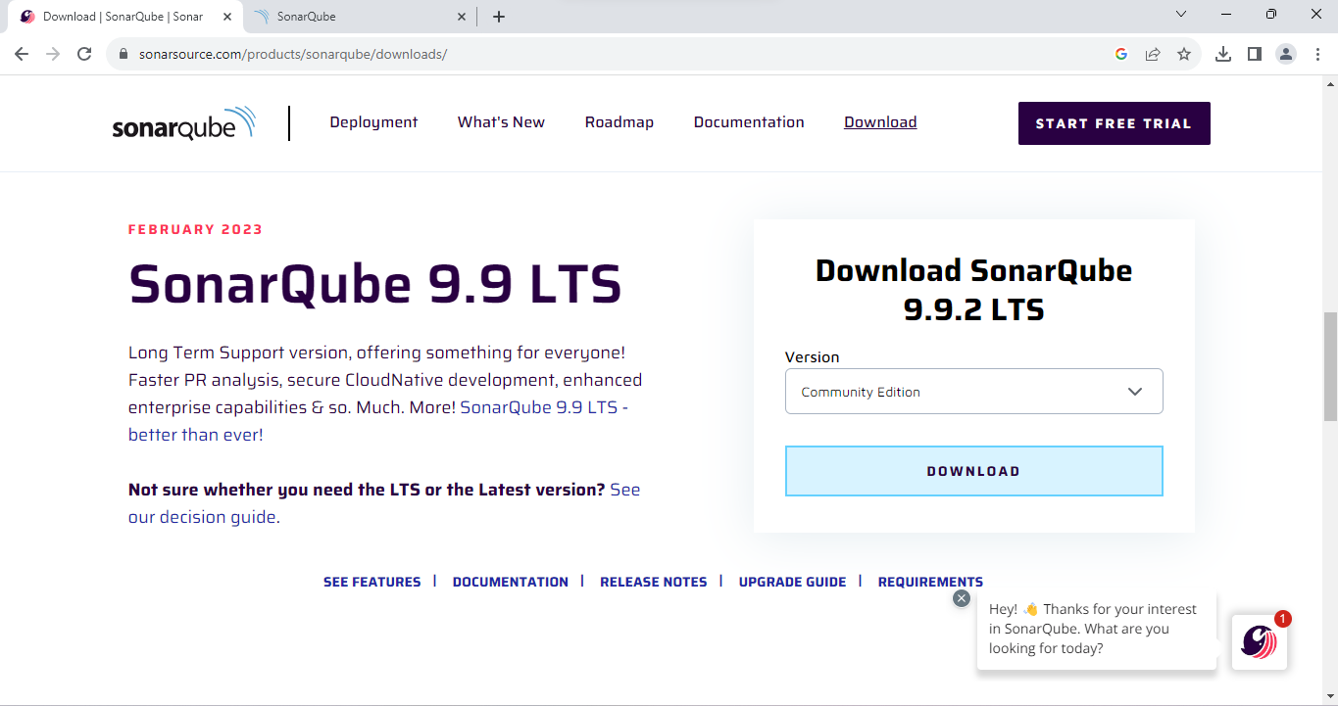

**Step2:- Extract all files,and then double click on startsonar.**

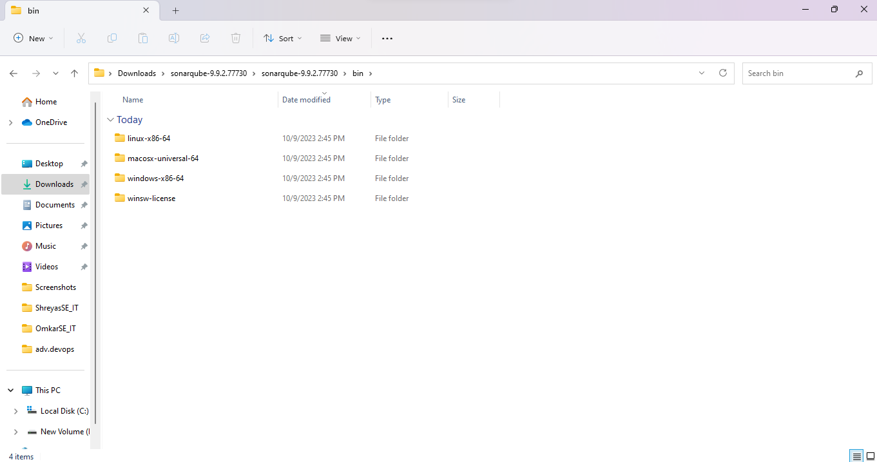

**Step3:- change your directory to the specified folder,go to command prompt**

**StartSonar.**

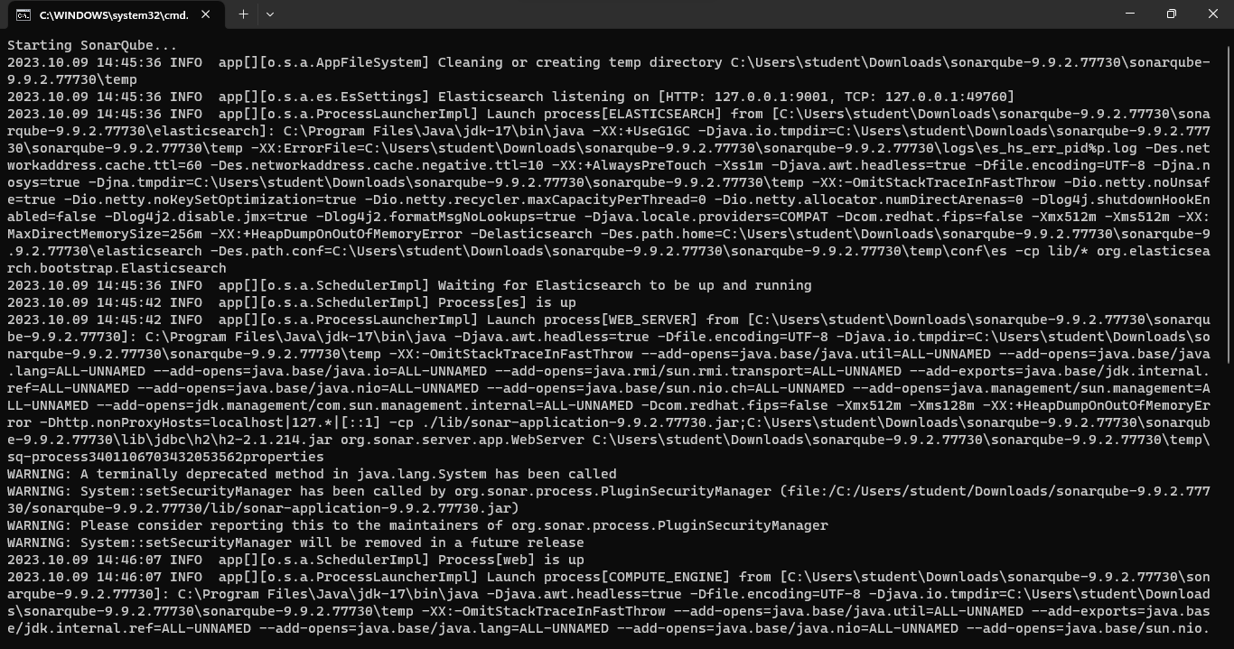

**Step4:- go to localhost:9000, enter the login id and password.**

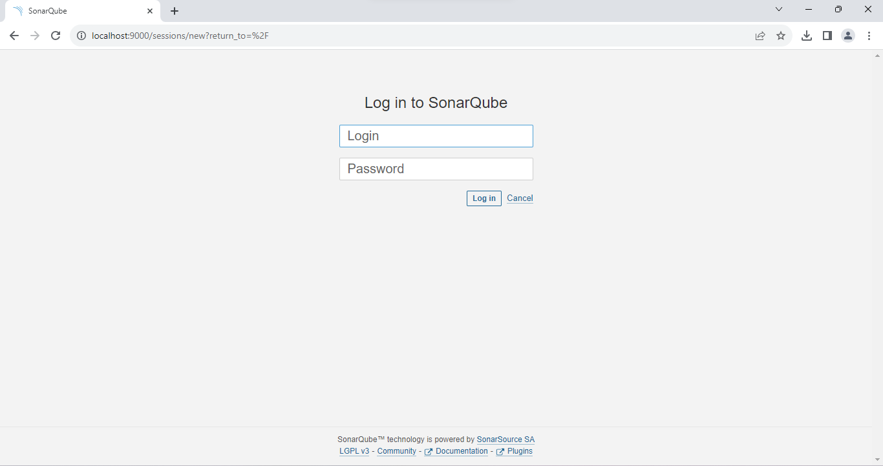

**Step5:- Here is the dashboard of sonarqube.**

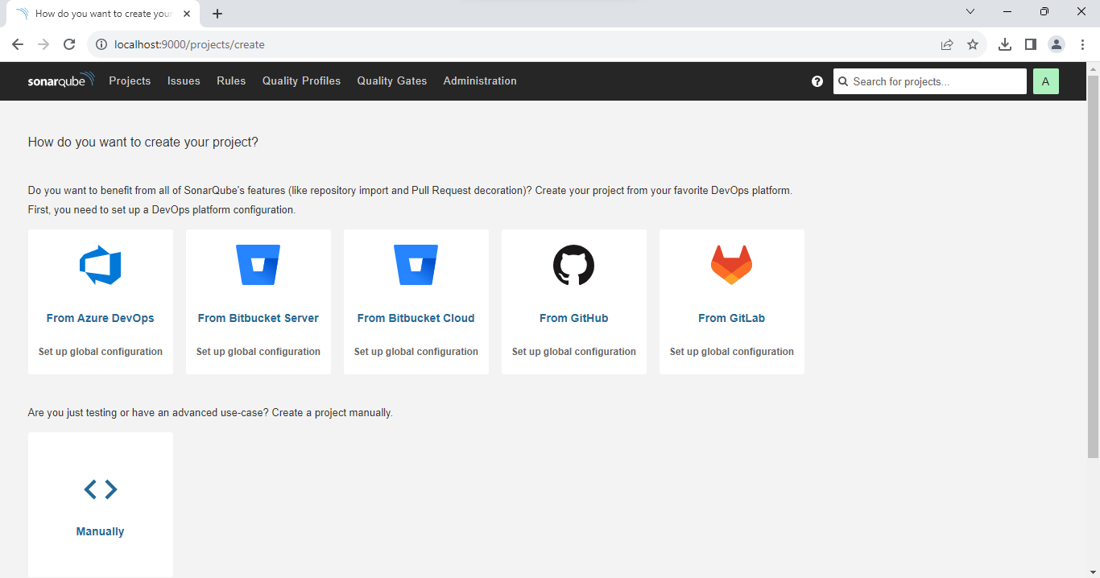

**Step6:- go to issues.**

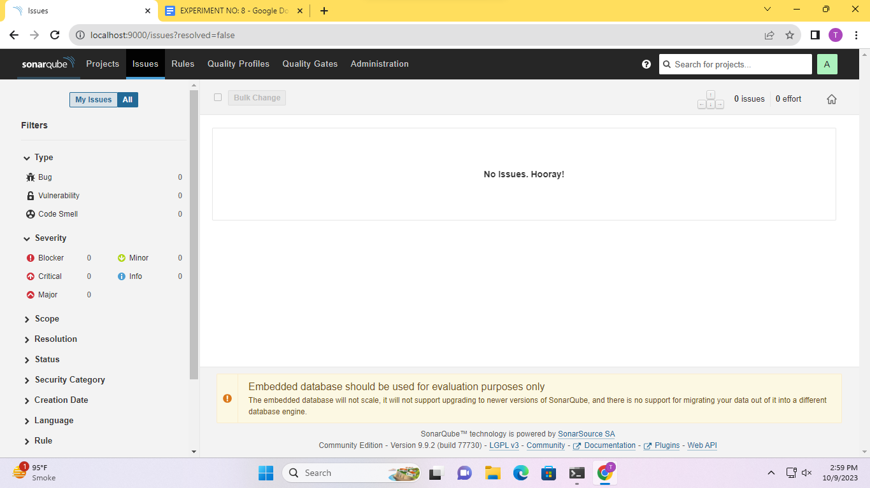

**Conclusion:-**